Dear South Africans in Sweden, Finland, Estonia, Latvia, and Lithuania

The South African Embassy in Stockholm received the following information from the IEC, regarding registration and to vote abroad in the 2024 Elections.

1. ON-LINE REGISTRATION TO VOTE ABROAD:
The IEC on-line portal for voter registration is open on their link (https://www.elections.org.za/). South African Nationals are encouraged to register online.
By scanning the QR code, users will be directed to the IEC portal for registration.
Alternatively, the portal can be accessed on the IEC website - https://www.elections.org.za/

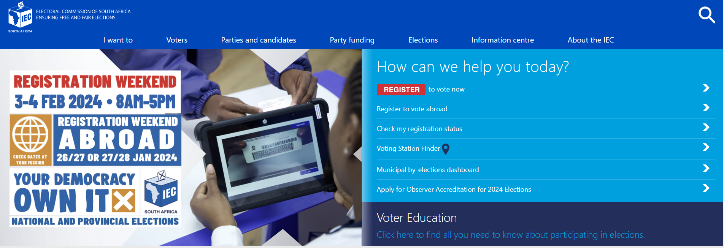

2. VOTER REGISTRATION WEEKEND:

On the weekend of 27 and 28 January 2024, the Embassy will be open for voter registration (08.00 – 17.00) to accommodate South African Nationals who either do not have access to, or were unable to, register online. Bring your SA ID Book/Card and SA Passport to register.

Regards
CONSULAR SECTION
StockholmE@dirco.gov.za
6th Floor, Alsnögatan 7, 116 41, Stockholm

